Project Synopsis:
ge

TOPIC: MINI PROJECT SYNOPSIS ON FITZONE – GYM &FITNESS PLATFOM

Submitted By :- Submitted to :-
Sy nopsis
Name: Prachi Dubey Faculty Name: Mr. Akash Kumar Choudhary
Id: 2415001121
Technical Trainer
Name: Nancy Jaiswal
Id: 2415001011

Name: Somya Agrawal
Id: 2415001587

Name: Himanshi Sharma
Id: 2415000681

Name: Vanshika Jaiswal
Id: 2415001744

DECLARATION

We hereby declare that the project titled “FitZone — Gym & Fitness Platform” is our original work and will be developed by us as part of our mini project. We will carry out the design, development, and testing of the application under the guidance of our technical trainer. The project will follow proper coding practices and version control using Git and GitHub.

Team Members :-

Prachi Dubey

Nancy Jaiswal

Somya Agrawal

Himanshi Sharma

Vanshika Jaiswal

ACKNOWLEDGEMENT

We would like to express our sincere gratitude to our technical trainer, Mr. Akash Kumar Choudhary, for his valuable guidance and support throughout the development of this project. We are also thankful to GLA University for providing us with the opportunity to work on this project. Finally, we thank our team members and everyone who supported us during the planning and development of FitZone.

INDEX

S.No | TOPIC | Page No.
1 | Introduction | 5 - 7
2 | Working Methodology Of the Project | 8
3 | Details About the Hardware and the Software | 9 - 10
4 | Idea of the Project | 11
5 | Objective | 12
6 | Availability | 13
7 | Module Description | 14
8 | DFD 0 level 1 level and 2 level | 15 – 16
9 | Bibliography | 17
10 | References | 18

INTRODUCTION

FitZone — Gym & Fitness Platform is a MERN-stack web application designed to showcase gym facilities, trainers, and membership plans. It provides users with an easy way to explore fitness services and gym information through a responsive interface. The project uses React.js for the frontend, Node.js and Express.js for backend development, and MongoDB for data storage. It aims to provide practical experience in full-stack web development, REST API integration, and Git/GitHub version control.

About the Project :-

FitZone is a web-based gym and fitness platform designed to showcase gym facilities, trainers, membership plans, and fitness-related services. The application will provide a user-friendly interface through which visitors can explore gym information, view available membership plans, and connect with the gym.

The project will be developed using the MERN stack, consisting of MongoDB, Express.js, React, and Node.js. It will follow REST API design principles and Git/GitHub version control practices.

Primary Reason to Choose This Project

The primary reason for choosing this project is to develop a practical full-stack web application that combines frontend development, backend development, database management, and API integration. It will also help us understand how a real-world gym website can organize its services and membership information in one platform.

The Main Objective of the Project

The main objective of FitZone — Gym & Fitness Platform is to develop a user-friendly and responsive web application that provides gym facilities, trainer profiles, and membership plans in one centralized platform. The project aims to simplify access to gym-related information while providing practical experience in MERN stack development, REST API integration, and database management

Scope Of the Project

- FITZONE is a user-friendly platform designed to make gym and fitness management simple and convenient.
- Users can create an account, explore gym and membership plans, view workout routines, and check trainer details.
- The platform provides exercise information, basic diet guidance, reminders, and fitness progress tracking.
- It helps both beginners and regular gym users stay organized and consistent with their workouts.
- The project can be extended in the future with a mobile app, online trainer consultation, wearable-device integration, personalized workout plans, and detailed fitness reports.
- Overall, FITZONE aims to provide the basic fitness services and information users need in one place..

Working Methodology Of the Project

Working

- User registers and logs in to the platform.
- Explore gym, membership plans, trainers, and workouts.
- Users can select suitable membership/workout plans.
- Track fitness activities and progress.
- Admin manages users, trainers, memberships, and workout details.

Methodology

- Requirement Analysis – Identify user and admin requirements.
- System Design – Design UI, modules, and database structure.
- Development – Build frontend using HTML, CSS, JavaScript and backend using Node.js.
- Database Integration – Use MongoDB to store and manage data.
- Testing – Test features and fix errors.
- Deployment – Deploy the completed FITZONE platform.

Flow:-

Requirement Analysis → Design → Development → Database → Testing → Deployment

Details About the Hardware and the Software

1. System Requirements
- A modern web browser such as Chrome, Edge, or Firefox.
- Internet connection for development, testing, and deployment.
2. Supported Operating Systems
- Windows 10/11
- Ubuntu/Linux
- macOS
3. Software Required
- Visual Studio Code
- Node.js and npm
- MongoDB
- MongoDB Compass
- Git and GitHub
- Modern web browser

4. Hardware Requirements

- RAM: Minimum 4 GB
- Processor: Intel Core i3 or equivalent
- Processor Speed: 2.0 GHz or higher
- Storage: Minimum 10 GB free space

6. Testing Technologies

- Manual Testing
- API Testing using Postman

7. Technology Stack

- Frontend: React.js, HTML, CSS, JavaScript
- Backend: Node.js, Express.js, REST APIs
- Database: MongoDB
- Version Control: Git and GitHub

Idea of the Project
The idea behind FitZone is to create a single digital platform for gym information and membership services. Instead of depending only on physical visits or separate information sources, users can explore the gym's facilities, trainers, and plans through a website.
The project will focus on a clean interface, organized information, and a proper connection between the frontend, backend, and database.

Objective

The main objectives of FitZone are :-

- To develop a responsive gym and fitness website.
- To provide information about gym facilities and services.
- To display trainer profiles and membership plans.
- To implement user registration and login functionality.
- To develop REST APIs using Express.js.
- To store and manage data using MongoDB.
- To understand full-stack MERN development.
- To practice Git and GitHub version control.
- To improve teamwork and project development skills.

Availability

FITZONE will be developed as a web-based application that can be accessed through modern web browsers.

- The platform will be compatible with both desktop and mobile devices.
- Users will be able to explore gym facilities, trainer profiles, membership plans, and fitness services.
- During development, the project will be available for local development and testing.
- After successful testing, it can be deployed online for users to access in the future.

Module Description

There are 3 Major Modules :-

1. User Module
- Registration/Login
- Profile
- Workout & diet information
- Progress tracking

2. Gym & Trainer Module
- Gym details
- Membership plans
- Trainer profiles
- Workout routines

3. Admin Module
- Manage users
- Manage trainers
- Manage memberships
- Manage gym/workout information

Data Flow Diagrams (DFD)

A Data Flow Diagram (DFD) illustrates how data moves through a system, including inputs, processes, and outputs. As its name indicates its focus is on the flow of information, where data comes from, where it goes and how it gets stored.

0-Level DFD :

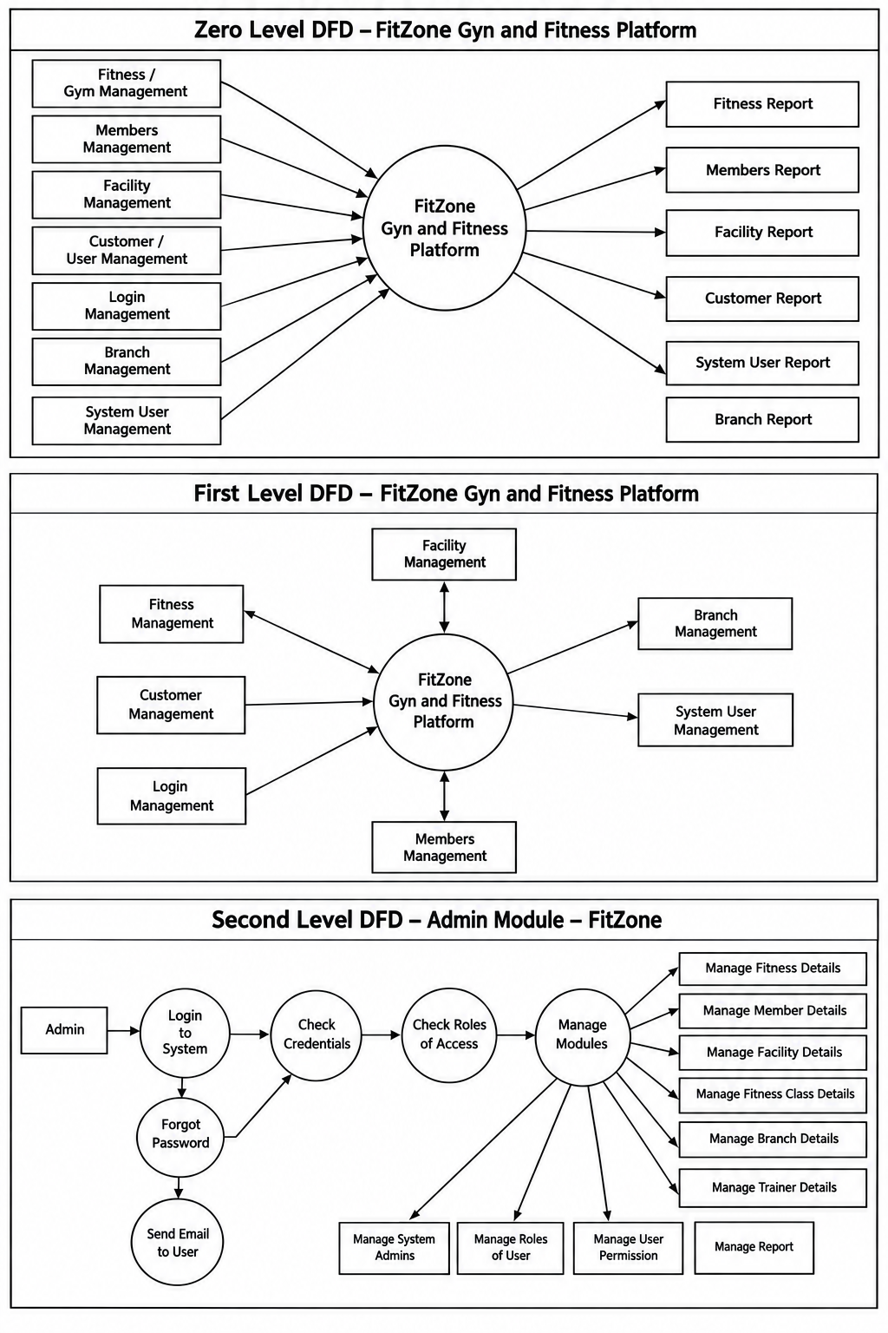

1-Level DFD :



2-Level DFD :



Bibliography

- MDN Web Docs — HTML, CSS and JavaScript documentation.

- W3Schools — Web development tutorials.

- React Documentation — Official React documentation.

- GeeksforGeeks — Web development and fitness-related project concept

References

- React.js Documentation — Official React Documentation
- Node.js Documentation — Official Node.js Documentation
- Express.js Documentation — Official Express.js Documentation
- MongoDB Documentation — Official MongoDB Documentation
- Git Documentation — Official Git Documentation

